**PROJECT DOCUMENTATION**

**ASSIGNMENT :** Create an automation framework

**DOCUMENTATION :** Selenium is an umbrella project for a range of tools and libraries that enable and support the automation of web browsers.

It provides extensions to emulate user interaction with browsers, a distribution server for scaling browser allocation, and the infrastructure for implementations of the [W3C WebDriver specification](https://www.w3.org/TR/webdriver/) that lets you write interchangeable code for all major web browsers.

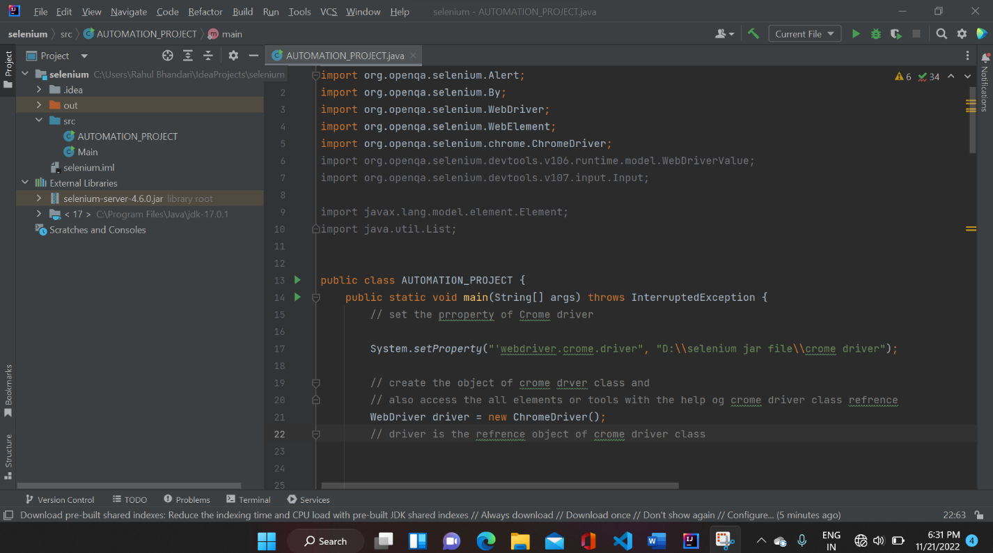

Let’s consider this particular project where we will try automating the process of booking a flight. Let’s take a look at how it’s done using Selenium.

Let’s divide the process into the various steps to understand the working of a project in a better way.

Steps:

1. We’ll start with initializing the browser driver and then log in to the web page(www. google.com)
2. Search [www.demo](http://www.demo) guru.com on google enigne.
3. After that creating a account and show password and user id
4. Successfully login with the help of automation tool
5. After that automatically deleting the customer
6. Also checking the checkbox and radio button with the help of automation tool
7. And the last show successfully launched and show result on terminal.

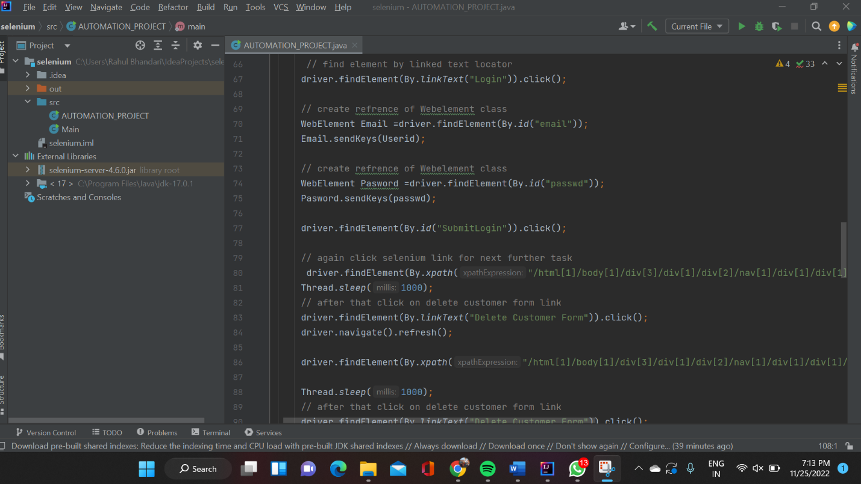

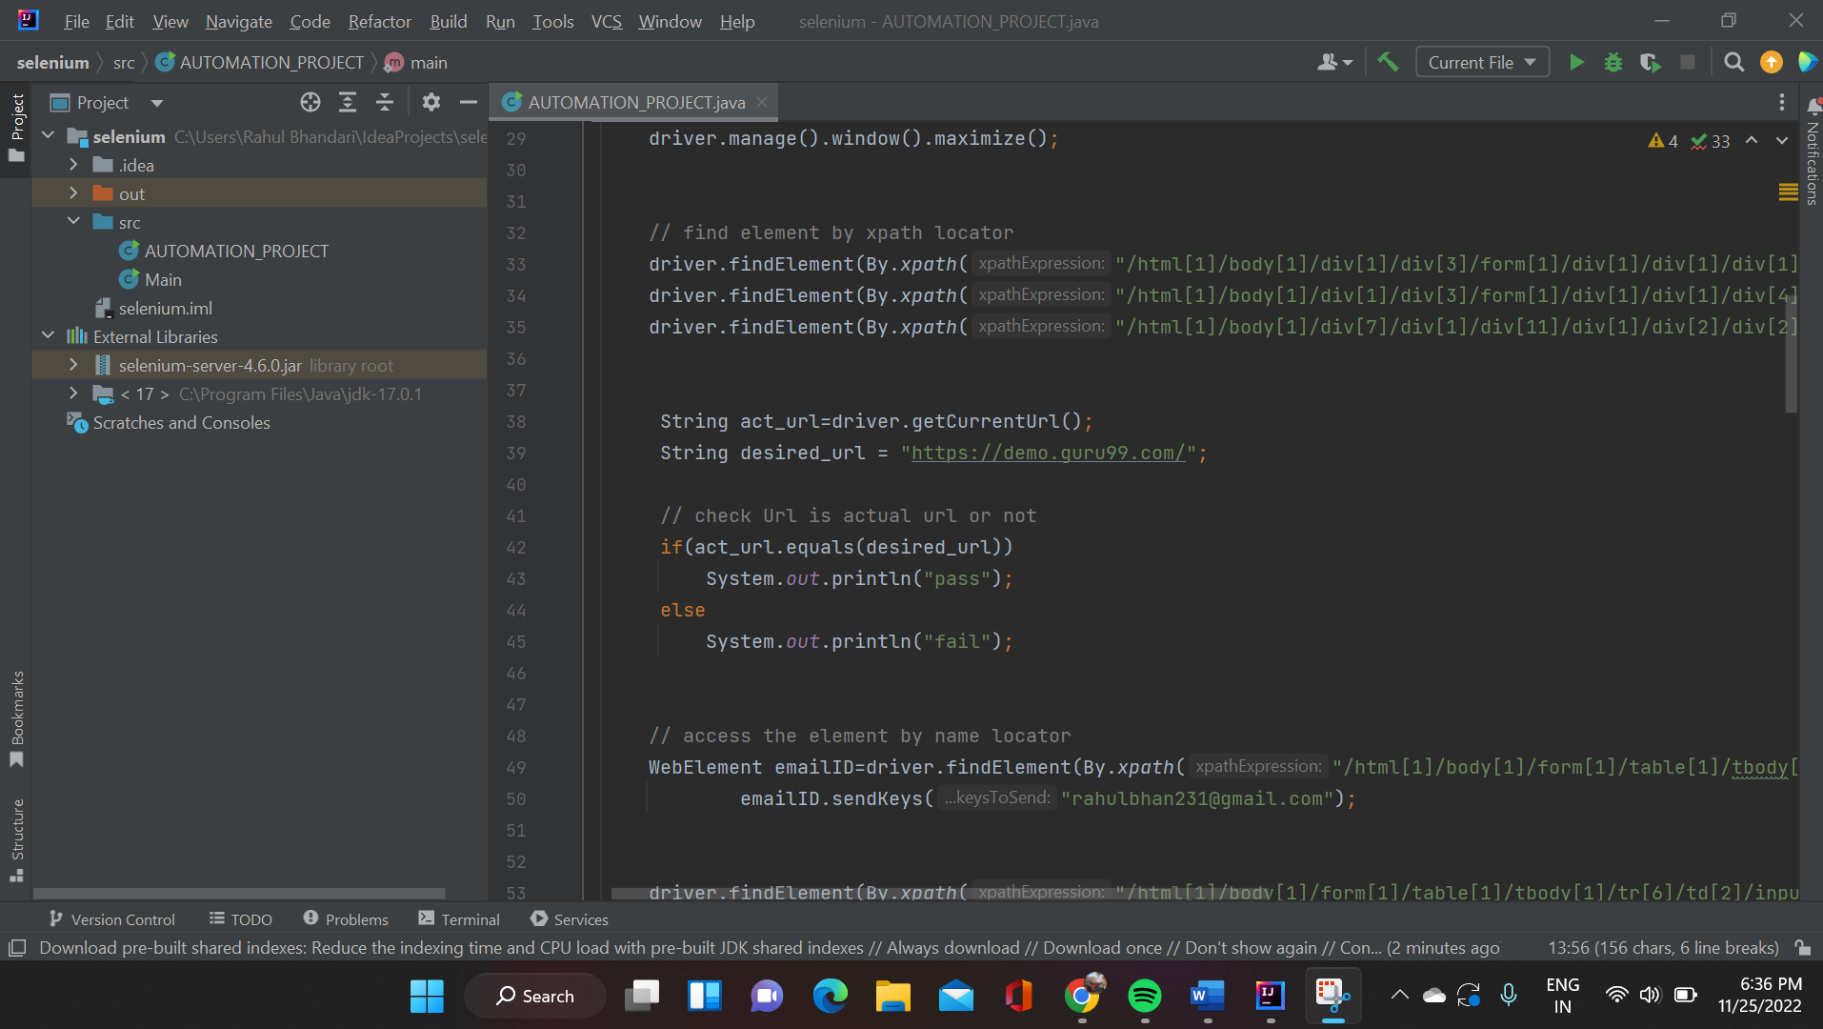

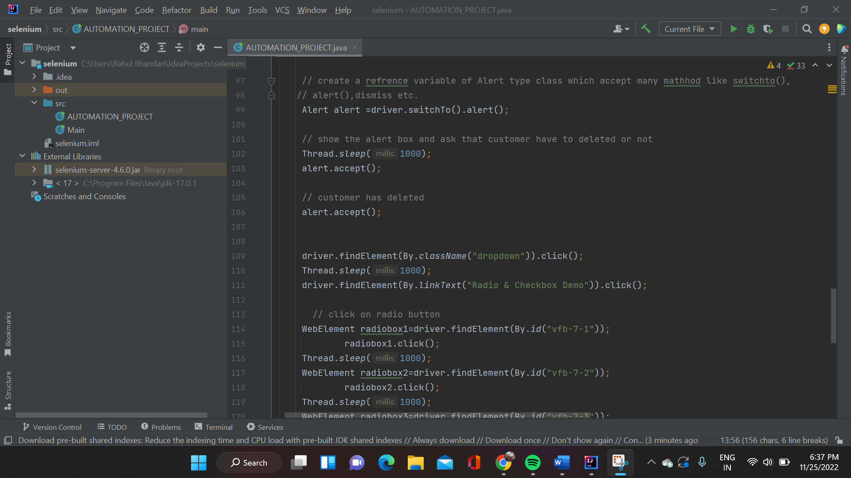

Tools and Technologies used:

|  |  |
| --- | --- |
| Editor or IDE | Intelli J |
| Technology | Java with multithread |
| Automation Tool | Selenium |
| Browser | Crome Browser |

Group number:1

|  |  |  |
| --- | --- | --- |
| Name | gmail | Phone number |
| Aditi Jain(Gp leader) | aditija978@gmail.com | 9350465283 |
| Rahul Bhandari | Rahulbhan231@gmail.com | 9729336110 |
| Sandali Singh | Sandalisingh1270@gmail.com | 9334919388 |
| Manoj | cbsa212563.mca.cbsa@cgc.edu.in | 7986021053 |
| shabnam | shabnamjindran009@gmail.com | 9592817019 |
| Paras sharma | cbsa212572.mca.cbsa@cgc.edu.in | 9780530286 |